  - GEMS School Catering Account – User Guide for GEMS Cashier

  - The School Cashier can collect cash on behalf of Ph7 and KEITA. The option to do this is available in OASIS->Fees Module->Fee Collection

  - 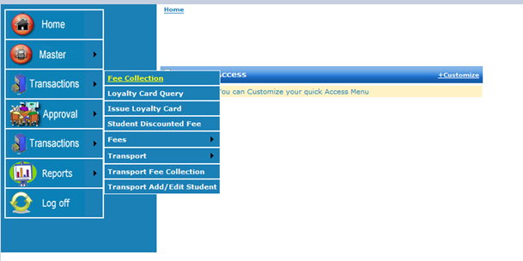

  - The Cashier has to search and select the student for whom Catering fees have to be collected. After the selection a button Catering Charge becomes visible, see screenshot below.

  - 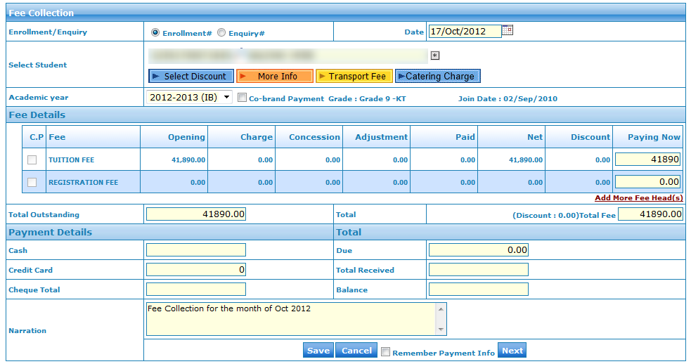

  - Catering Cash Collection: There are 3 options to select…
- Cash Recharge: The Cashier will enter the amount, minimum 50 Aed (see red mark)
- Meal Programme: select checkbox, an amount and date range will appear automatically, minimum days are 30 academic days and maximum days are for current academic term. The cashier can modify the date range.
- Meal Vouchers: enter quantity, based on the meal rate the amount is automatically calculated.
- Errors and Refunds: Errors (when a wrong student was selected and a reversal is required), or Refund (when a students is taking a TC) you can enter a negative amount, in screen shot the “Status” shows current student balance as 50.

After entering the values click on save.

  - 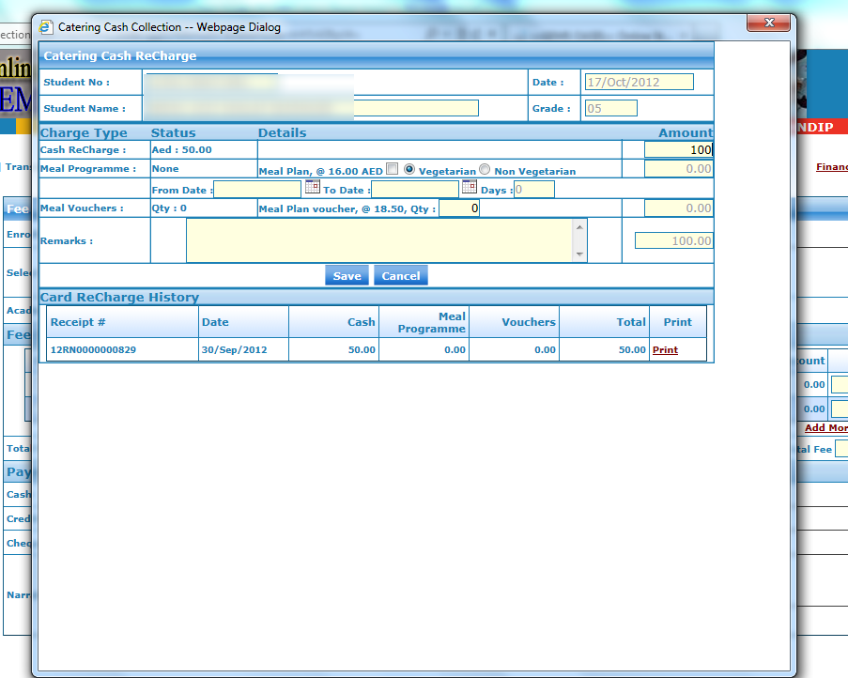

  - Receipt printing: after saving the record, a receipt is printed automatically, which can be given to the parent.

  - 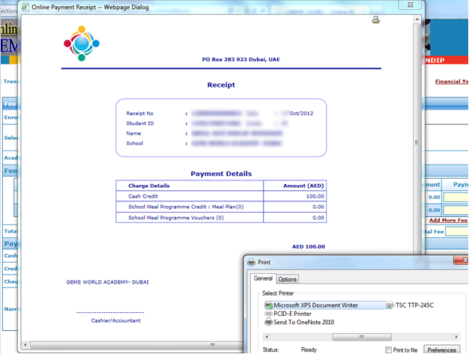

  - Catering Cash Collection Report: The cash collected for Ph7 and KEITA is NOT posted to OASIS. This cash, along with the report shown below, should be handed over to the Ph7 and KEITA Cashier at the end of each day.

  - 